# DNS Zone Transfer

The process of coping DNS zone data from one DNS sever to another. This is primarily used to synchronize DNS information b/w primary to secondary server ensuring redundancy and reliability. Zone transfer are crucial maintaining accurate and consistence DNS information across multiple servers, allowing for continued name resolution even if one server fails.

1. Full Zone transfer (AXFR - Authoritative Zone Transfer)
2. Incremental zone transfer(IXFR)

**Full Zone transfer (AXFR - Authoritative Zone Transfer) :**

This method involves transferring the complete DNS zone file from a primary server to a secondary server. It's a straightforward process but can be less efficient if only a few records have changed.

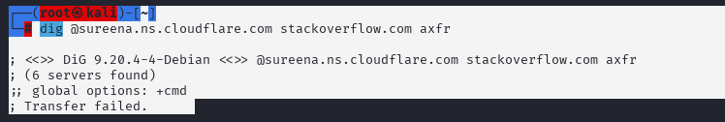

**Incremental zone transfer(IXFR) :**

This method transfers only the new or modified records since the last transfer. It's more efficient than AXFR when there are only minor changes to the zone file.

